

ANALYSIS DOCUMENT

FOR INFORMATION

DEVELOPMENT

SYSTEM -

PROJECT SCOPE AND

PROCESS MODELS

Project Phase 3

Take One movie Theatre Ticketing System

 | GROUP 19
Johané le Roux | 31614744
Christopher Slaghuis | 31713858
Jean Marx | 32313845
Reinhardt Nel | 27327884
James Uys | 28461789

Project Scope and Process Model Phase 3 Group 19

Contents

Project Scope 2

Process Models 4

Maintain Clients 4

Maintain Movies 5

Maintain Movie Schedule 6

Maintain Genres 7

Maintain Special Occasions 8

Sell Tickets 9

Marking Guide 10

1 | P a g e
Project Scope and Process Model Phase 3 Group 19

Project Scope

The main objective of this project is to provide an automated computerized system for the Take One movie theatre. The project must automate the daily business processes, provide extensive business reporting to support the business system and make tickets sales more technologically orientated. The system must provide extensive Help functionality to clients as well as employees using the system, backup functionality for future use and data must be protected against unwanted access to the system. Before the system can be used by clients and employees, all previous history data must be uploaded to the new system from the existing Excel system. The FAST methodology, which follows several phases, will be used to ensure a formal approach to the development and the implementation of the system. The following functionality will be included in the scope of this project.

The system must include functionality for the following:

- Maintain clients

- Maintain movie schedule

- Maintain genres

- Maintain special occasions

- Maintain movies

- Book seats online

  - Notify client about ticket information when sale is complete.

  - The notification will include their movie ticket code.

  - Show seat that are booked.

- Selling tickets (at the movie theatre)

In addition, the system must satisfy the following non-functional requirements:

- Extensive Help function for clients as well as for employees

- Provide unique identifiers for employees using the system to ensure secure and authorized access to the system

- The current database will hold the data for the movies that are showing at the theatre (all data and information regarding the movies), movies that was shown per time period (not currently) and special occasions that was hosted by the movie theatre.

- Queries performed by the employees should take no longer than 3 seconds.

- The system will be accessible by two types of users. The authorized employees will have access to all functionality of the system and will be able to change the database as they wish. The second type of users will be the client using the system to book tickets

2 | P a g e
Project Scope and Process Model Phase 3 Group 19

for movies either over the Internet or at the counter at the movie theatre. The clients will not have access to databases or the functionality of the system.

- The system must be able to export data when needed by the user

- The user must be able to request reports e.g. List of movies per time period; Top 10 movie genres per time period (e.g. comedy, drama, action); Top 10 movies per time period (time of day, day of weekend); Top 10 movies per schedule.

3 | P a g e
Project Scope and Process Model Phase 3 Group 19

Process Models

Maintain Clients
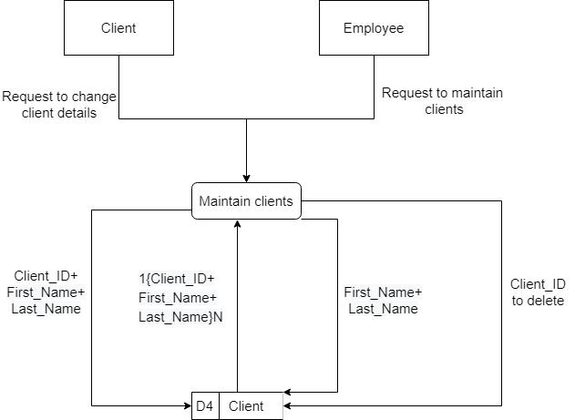

4 | P a g e
Project Scope and Process Model Phase 3 Group 19

Maintain Movies
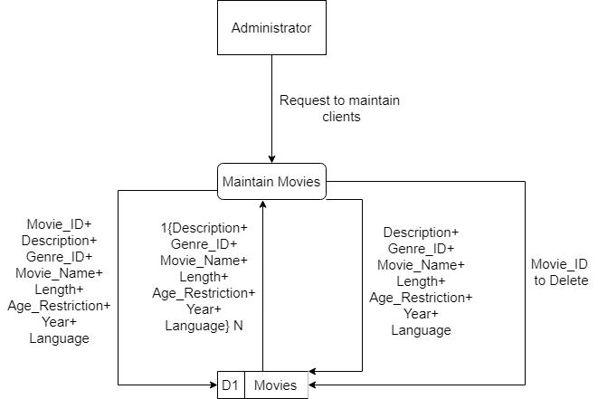

5 | P a g e
Project Scope and Process Model Phase 3 Group 19

Maintain Movie Schedule
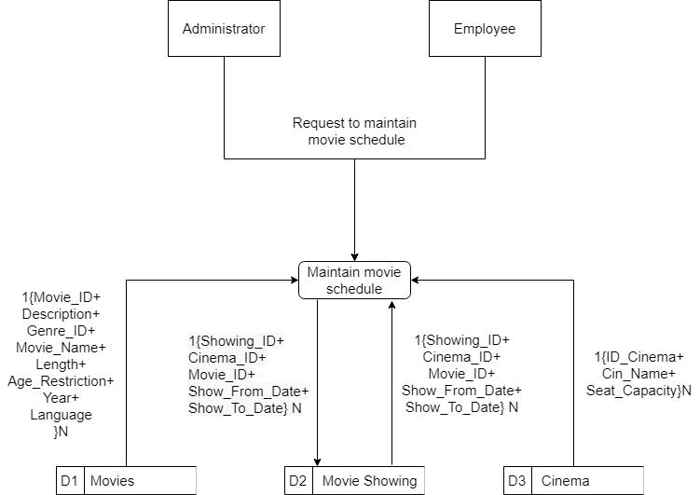

6 | P a g e
Project Scope and Process Model Phase 3 Group 19

Maintain Genres
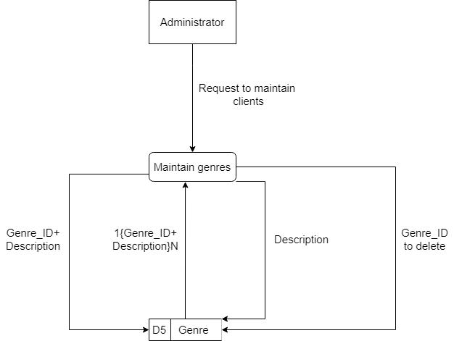

7 | P a g e
Project Scope and Process Model Phase 3 Group 19

Maintain Special Occasions
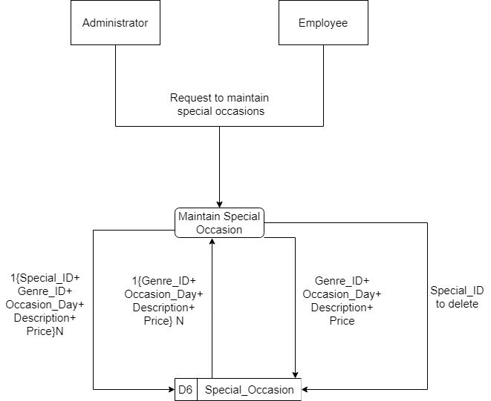

8 | P a g e
Project Scope and Process Model Phase 3 Group 19

Sell Tickets
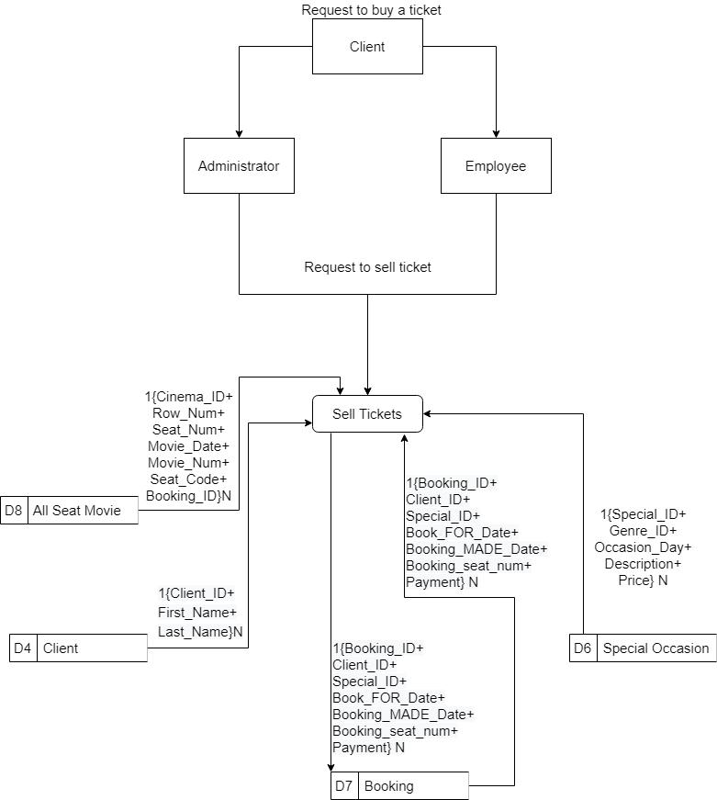

9 | P a g e
Project Scope and Process Model Phase 3 Group 19

Marking Guide

CMPG213 Marking Guide for Analysis Document 2020

Group Number: |  | 19
Members: | Johané le Roux |  | Student No: 31614744
 | Christopher Slaghuis |  | 31713858
 | Jean Marx |  | 32313845
 | Reinhardt Nel |  | 27327884
 | James Uys |  | 28461789

System to implement: |  |  | Take One Movie Theatre
 |  |  | Item | Maximum | Group’s
 |  |  |  | Mark | Mark
 | Project scope (Updated from previous documents and specific) |  |  | 5
 | Use-case diagram (must include association relationships and |  |  | 15
 | at least one <<depends on>> relationship)
 | • | Use-cases
 | • | Actors
 | • | Associations
 | • | <<depends on>> relationship
 | • Frame and system name
 | Fully attributed data model (example Fig 8-16 P 297) |  |  | 20
 | • | Entities
 | • | Attributes
 | • | Primary keys
 | • | Foreign keys
 | • Relationships (weak/strong, verb, cardinality)
 | • | 3NF
 | Process models (Only primitive diagrams, i.e. lowest level of |  |  | 30
 | detail)
 | • | Agents
 | • | Processes
 | • | Data Stores
 | • | Data flows
 | Scope, Use-case diagram, data models and process models |  |  | 10
 | are integrated, e.g.
 | • dataflows contain attributes of entities,
 | • all actors appear as agents in process models,
 | • all use cases appear as processes in process models
 | • all entities appear as data stores in process models
 | • all use-cases refer to entities in data model
 | TOTAL |  |  | 80

10 | P a g e
Project Scope and Process Model Phase 3 Group 19

Comments:

_________________________________________________________

_________________________________________________________

_________________________________________________________

_________________________________________________________

11 | P a g e

